ASSIGNMENT-4

**Make 4 web pages**

**1.Starting with create account(POST request)**

**2.login page(GET request) and check if the user should be logged in or not**

**3. After login go to a page where u ll be having three inputs (image url, title, description)**

**4. After the submitting the form, restaurant.html should be loaded with the added data**

<!DOCTYPE html>

<html lang="en">

<head>

    <meta charset="UTF-8">

    <meta http-equiv="X-UA-Compatible" content="IE=edge">

    <meta name="viewport" content="width=device-width, initial-scale=1.0">

    <title>Document</title>

</head>

<body>

    <div id="create_account">

        <input type="text" id="email" placeholder="enter email">

        <input type="text" id="name" placeholder="enter name">

        <input type="number" id="number" placeholder="number">

        <input type="password" id="password" placeholder="enter password">

        <button onclick="submitData()">create_account</button>

        <button onclick="cancel()">CANCEL</button>

    </div>

    <script src="index.js"></script>

</body>

</html>

const takenemail=document.getElementById("email");

const takenpassword=document.getElementById("password");

function submitData(){

    if(takenemail.valeu !== "" && takenpassword.value !== ""){

        const obj ={

            id:Date.now(),

            email:takenemail.value,

            password:takenpassword.value,

        };

        fetch("http://localhost:8080/myData",{

    method:"POST",

    headers :{

        "Content-Type": "application/json"

    },

    body: JSON.stringify(obj),

})

.then((res)=>res.json())

.then((data) => {console.log(data);

    alert("Created Account");

})

    .catch((err) => console.log(err));

}

else{

    alert("Fill in all the fields");

}

window.location.href = "./login.html";

}

function cancel() {

    // Redirect to hotel.html

    window.location.href = "./login.html";

  }

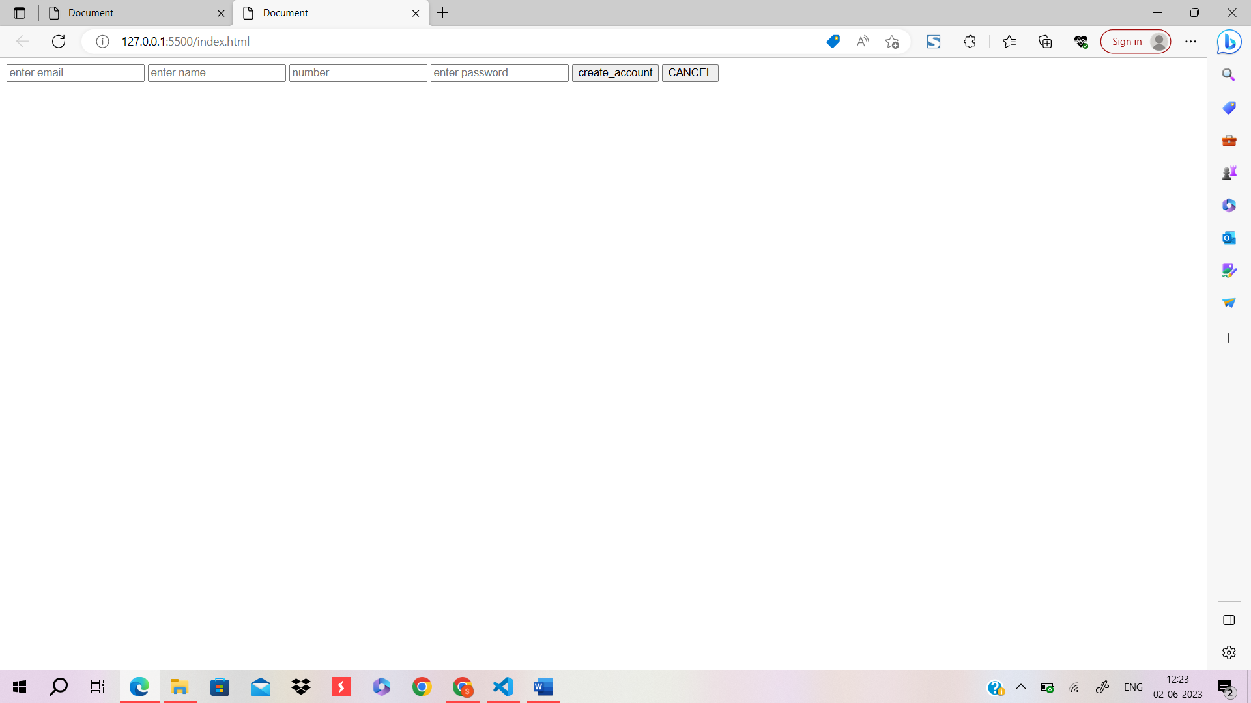

<!DOCTYPE html>

<html lang="en">

  <head>

    <meta charset="UTF-8" />

    <meta http-equiv="X-UA-Compatible" content="IE=edge" />

    <meta name="viewport" content="width=device-width, initial-scale=1.0" />

    <title>Document</title>

  </head>

  <body>

    <div>

      <input type="text" placeholder="Enter Email" id="email" />

      <input type="password" placeholder="Enter Password" id="password" />

      <button onclick="findUser()">Login</button>

    </div>

    <script src="login.js"></script>

  </body>

</html>

const email = document.getElementById("email");

const pass = document.getElementById("password");

function findUser() {

  fetch("http://localhost:8080/myData", {

    method: "GET",

  })

    .then((res) => res.json())

    .then((data) => {

      console.log(data);

      const user = data.find(

        (el) => el.email === email.value && el.password === pass.value

      );

      console.log(user);

      if (user) {

        alert("Logged in Successfully");

      } else {

        window.location.href = "./index.html";

      }

      window.location.href = "./recipe.html";

    });

  console.log(data);

}

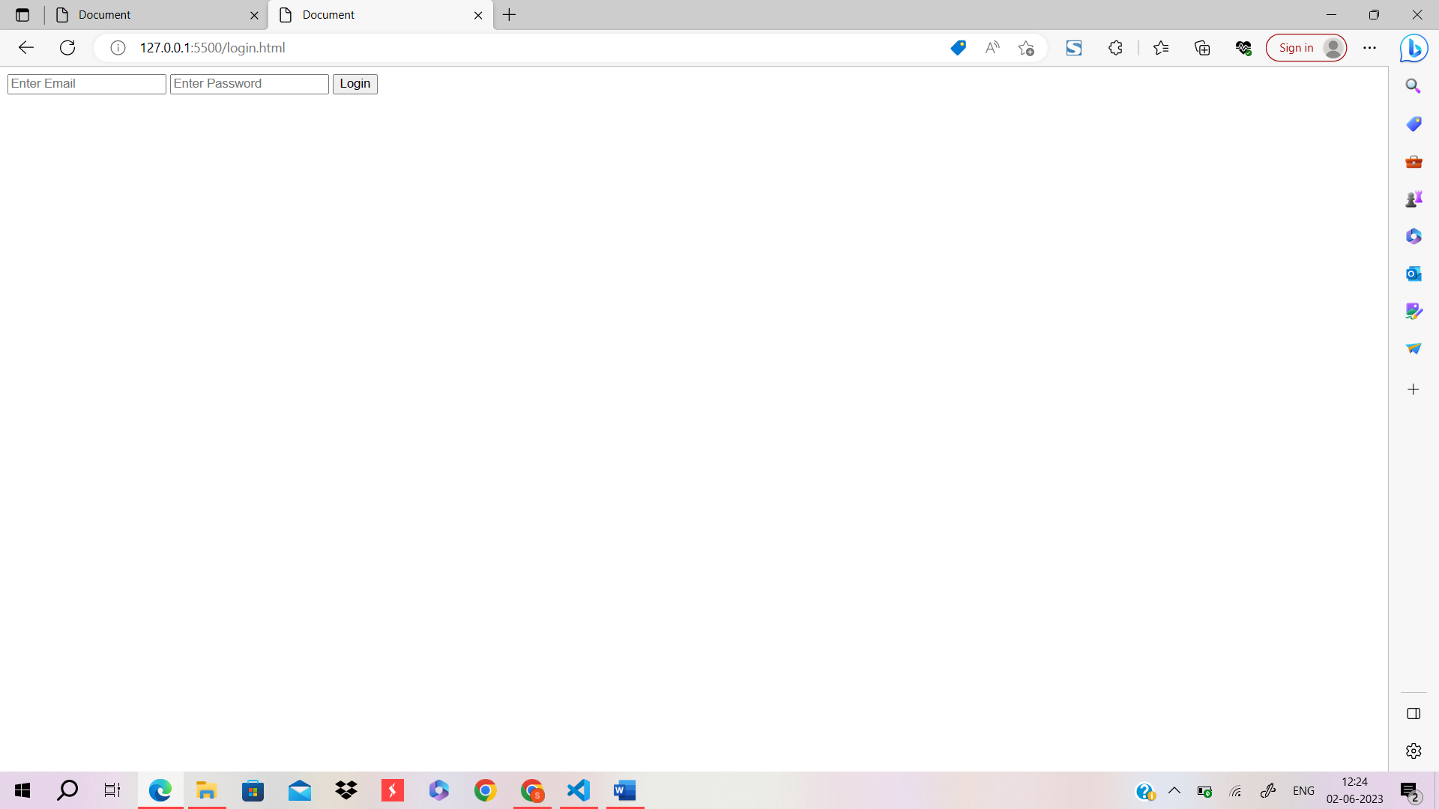

<!DOCTYPE html>

<html lang="en">

<head>

    <meta charset="UTF-8">

    <meta http-equiv="X-UA-Compatible" content="IE=edge">

    <meta name="viewport" content="width=device-width, initial-scale=1.0">

    <title>Document</title>

</head>

<body>

    <div>

        <input type="text" id="name" placeholder="Enter recipe name"><br>

        <input type="url" id="l" placeholder="enter image link"><br>

        <input type="text" id="desc" placeholder="description">

        <button onclick="recip()">SUBMIT</button>

        <button onclick="cancel()">CANCEL</button>

    </div>

    <script src="recipe.js"></script>

</body>

</html>

const takename=document.getElementById("name");

const takenurl=document.getElementById("l");

const takedesc=document.getElementById("desc");

function recip(){

    if(takename.value !== "" && takenurl.value !== "" && takedesc.value !== ""){

        const obj1 ={

            dish:takename.value,

            link:takenurl.value,

            description:takedesc.value,

        };

        fetch("http://localhost:8080/myrecipe",{

    method:"POST",

    headers :{

        "Content-Type": "application/json"

    },

    body: JSON.stringify(obj1),

})

.then((res)=>res.json())

.then((data) => {console.log(data);

    alert("Details Saved");

})

    .catch((err) => console.log(err));

}

else{

    alert("Fill in all the fields");

}

window.location.href = "./hotel.html";

}

function cancel() {

    // Redirect to hotel.html

    window.location.href = "./hotel.html";

  }

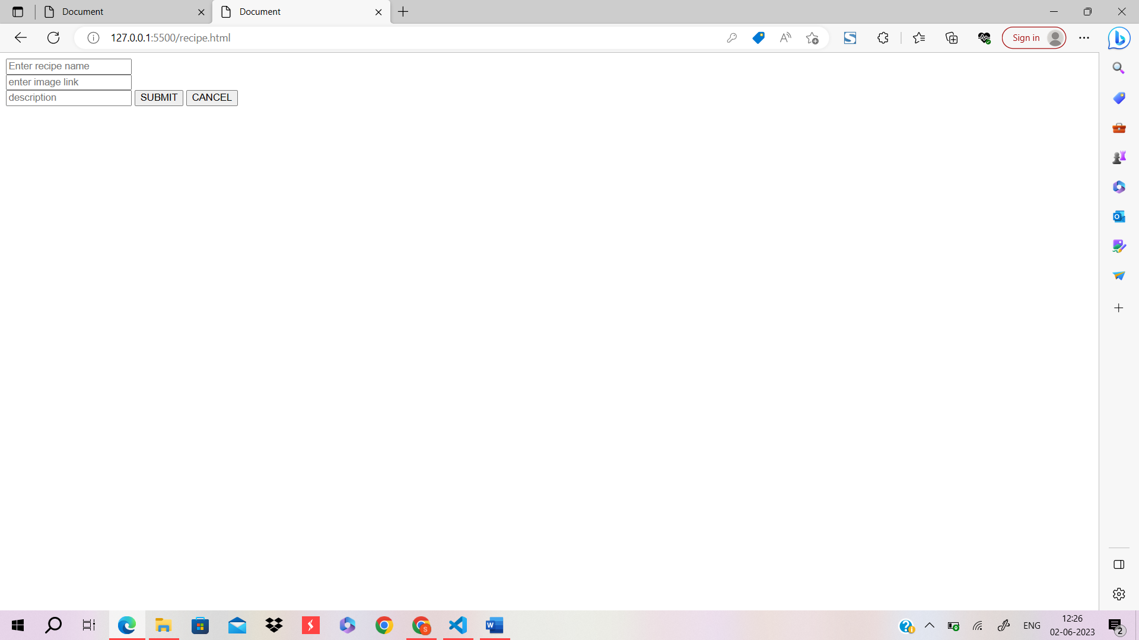

<!DOCTYPE html>

<html lang="en">

<head>

    <meta charset="UTF-8">

    <meta http-equiv="X-UA-Compatible" content="IE=edge">

    <meta name="viewport" content="width=device-width, initial-scale=1.0">

    <title>Document</title>

    <link rel="stylesheet" href="hotel.css">

</head>

<body>

    <div id="nav">

        <h1>NONVEG-WORLD</h1>

        <input type="text" name="dishes" id="dish" placeholder="Search for Dishes">

        <button>MENU</button>

    </div>

    <div id="hotel"></div>

    <script src="hotel.js"></script>

</body>

</html>

#hotel{

    width: 1600PX;

    border: 5px black solid;

    background-color: yellowgreen;

    display: grid;

    grid-template-columns: repeat(3, 1fr);

    gap :5px;

    background-image: linear-gradient(

    to bottom right,

    orange

    ,

    darkorange

  );

  position: relative;

  top:190px;

}

#hotel img{

    border: 5px black solid;

    width:350px;

    height:500px;

    object-fit: cover;

    border-radius: 30px;

    box-shadow:3px 3px 10px;

}

#hotel h1{

    text-align: center;

    font-weight: bolder;

    font-family:Georgia, 'Times New Roman', Times, serif ;

    color: #062a0f;

    text-shadow: 2px 2px;

}

#hotel p{

    text-align: center;

    color: bisque;

    font-weight: bolder;

    font-family:Georgia, 'Times New Roman', Times, serif ;

}

#hotel button{

  font-size: 16px;

  height:25px;

  width: 150px;

    border-radius: 10px;

    color: purple;

}

#hotel div{

    border: 1px solid;

    text-align:center;

    margin:5px;

    box-shadow:3px 3px 8px;

  }

  #nav{

    height:200px;

    width: 100%;

    z-index:1;

    position:fixed;

    top:0px;

    left:0px;

    right:0px;

    /* background-image: url("https://burst.shopifycdn.com/photos/flatlay-iron-skillet-with-meat-and-other-food.jpg?width=1200&format=pjpg&exif=1&iptc=1");

      background-repeat: no-repeat;

      background-size: cover; */

      background-color: orangered;

      border: 2px solid black;

  }

  #nav h1{

    position:absolute;

    left:640px;

    top:15px;

    font-family: 'Times New Roman', Times, serif;

  }

  #nav input{

    position: absolute;

    right:200px;

    bottom:10px;

    height:30px;

    width:300px;

    background-color:rgb(246, 242, 242);

    border: 2px solid black;

    border-radius: 10px;

  }

  #nav button{

    position:absolute;

    right: 100px;

    bottom:10px;

    height:35px;

    width:80px;

    background-color:rgb(246, 242, 242);

    border: 2px solid black;

    border-radius: 10px;

  }

fetch("data.json")

  .then((response) => response.json())

  .then((data) => {

    const myrecipe = data.myrecipe;

    const dishesContainer = document.getElementById("hotel");

    myrecipe.forEach((recipe) => {

      const div = document.createElement("div");

      const image = document.createElement("img");

      image.src = recipe.link;

      const dishTitle = document.createElement("h1");

      dishTitle.innerText = recipe.dish;

      const desc = document.createElement("p");

      desc.innerText = recipe.description;

      const button1 =document.createElement("button");

        button1.innerText="show Description";

        button1.addEventListener("click", () =>{

            desc.innerText=recipe.description;

            localStorage.setItem("id",JSON.stringify(recipe.id));

        });

        const button2 =document.createElement("button");

        button2.innerText="click for Hide";

        button2.addEventListener("click", () =>{

            desc.innerText="";

        });

      const updatebutton = document.createElement("button");

      updatebutton.innerText= "UPDATE";

      updatebutton.addEventListener("click",() => {

        const updatetitle = prompt("");

        const newobj = {

          dish : updatetitle,

          link: recipe.link,

          description: recipe.description,

        };

        fetch(`http://localhost:8080/myrecipe/${recipe.id}`, {

          method: "PUT",

          headers :{

            "Content-Type": "application/json"

        },

        body: JSON.stringify(newobj),

        })

        .then((res) => {

          alert("updated title suscessfully");

        })

        .catch((err) => {

          alert("error occured while updating"+err);

        });

      });

      const deletebutton = document.createElement("button");

      deletebutton.innerText= "DELETE";

      deletebutton.addEventListener("click", () => {

        fetch(`http://localhost:8080/myrecipe/${recipe.id}`, {

          method: "DELETE",

        })

        .then((res) => {

          alert("Deleted the item");

        })

        .catch((err) => {

          alert("error occured while deleting"+err);

        });

      });

      // const showDetails=document.createElement("button");

      //   showDetails.innerText="Show Details";

      //   showDetails.addEventListener("click",()=>

      //   {

      //       localStorage.setItem("id",JSON.stringify(el.id));

      //   })

      div.append(image, dishTitle, desc,button1,button2,updatebutton,deletebutton);

      dishesContainer.append(div);

    });

  })

  .catch((error) => {

    console.error("Error fetching recipe data:", error);

  